
- What is Spring Framework?
Spring is a powerful lightweight application development framework used for Java Enterprise Edition (JEE). In a way, it is a framework of frameworks because it provides support to various frameworks such as Struts, Hibernate, Tapestry, EJB, JSF etc. The framework in broader sense can be defined as a structure using which you can solve many technical problems. You can say that, the Spring Framework is a comprehensive tool for supporting applications using Java programming language.
Roderick B. Johnson, an Australian computer specialist officially released the Spring Framework in 2004. Since its origin, Spring Framework has released many versions.

- Why use Spring?
Below are listed some of the notable features that Spring provides us –
- Spring covers the important areas that other frameworks don’t. It mainly focuses on how to provide a better way to deal or manage business objects.
- Spring is a lightweight container which contains and manages the life cycle of application objects.
- Spring enables us to build applications using Plain Old Java Objects (POJOs) and to apply business related services non-invasively to POJOs. POJO programming enables continuous integration and testability.
- Spring Framework provides powerful abstraction to JavaEE specifications such as JMS, JDBC, JPA and JTA.
- It provides loose coupling among the classes using Dependency Injection.
- Spring supports Aspect Oriented Programming, which aims at increasing modularity of the application, by separating the crosscutting concerns (transaction management, Security, Logging, etc.) from the actual business logic implementations.
- Major benefit is its layered architecture, which allows us to be selective about which components we should use while providing a well-integrated framework for enterprise java application development.
- Features Of Spring Framework
- Lightweight: Spring Framework is lightweight with respect to size and transparency.
- Inversion Of Control (IOC): In Spring Framework, loose coupling is achieved using Inversion of Control. The objects give their own dependencies instead of creating or looking for dependent objects.
- Aspect Oriented Programming (AOP): By separating application business logic from system services, Spring Framework supports Aspect Oriented Programming and enables cohesive development.
- Container: Spring Framework creates and manages the life cycle and configuration of application objects.
- MVC Framework: Spring Framework is a MVC web application framework. This framework is configurable via interfaces and accommodates multiple view technologies.
- Transaction Management: For transaction management, Spring framework provides a generic abstraction layer. It is not tied to J2EE environments and it can be used in container-less environments.
- JDBC Exception Handling: The JDBC abstraction layer of the Spring Framework offers an exception hierarchy, which simplifies the error handling strategy.
Since its origin till date, Spring has spread its popularity across various domains. Spring Framework now is the foundation for various other Spring Projects that have come up in the offerings in the last two to three years. Check the below image to find out various projects undertaken by Spring.
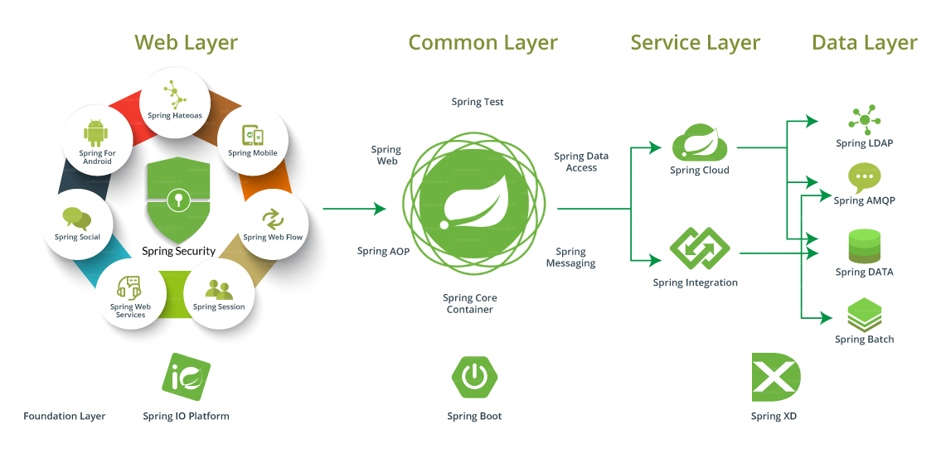
- Spring Framework Architecture
As you can see in the diagram below, Spring Framework architecture is an arranged layered architecture which consists of different modules. All the modules have their own functionalities that are utilized to build an application. There are around 20 modules which are generalized into Core Container, Data Access/ Integration, Web, AOP (Aspect Oriented Programming), Instrumentation, and Test. Here, developer is free to choose the required module. It’s modular architecture enables integration with other frameworks without much hassle.
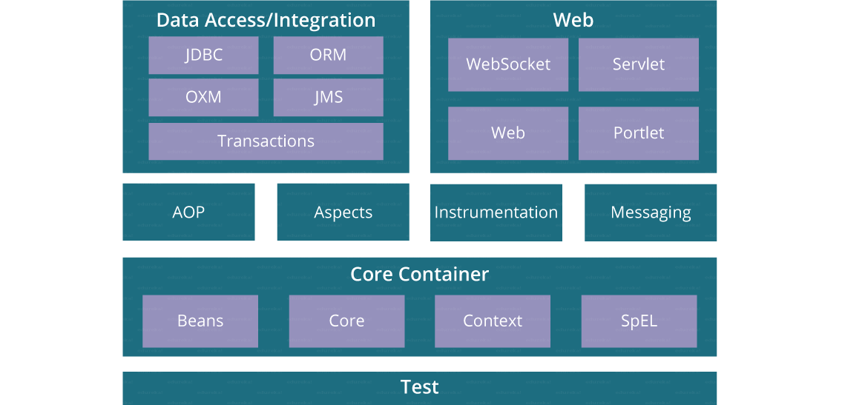

Modules Of Spring Framework:

A] Spring Core Container:
- Spring Core: This module is the core of the Spring Framework. It provides implementation for features like IoC (Inversion of Control) and Dependency Injection with singleton design pattern.
- Spring Bean: This module provides implementation for the factory design pattern through BeanFactory.
- Spring Context: This module is built on the solid base provided by the Core and the Beans modules and is a medium to access any object defined and configured.
- Spring Expression Languages (SpEL): This module is an extension to expression language supported by Java server pages. It provides a powerful expression language for querying and manipulating an object graph, at runtime.

B] Spring Data Access Integration:
- JDBC: This module provides JDBC abstraction layer which eliminates the need of repetitive and unnecessary exception handling overhead.
- ORM: ORM stands for Object Relational Mapping. This module provides consistency/ portability to our code regardless of data access technologies based on object oriented mapping concept.- JPA,JDO,Hibernate,iBatis,MyBatis,TopLink
- OXM: OXM stands for Object XML Mappers. It is used to convert the objects into XML format and vice versa. The Spring OXM provides an uniform API to access any of these OXM frameworks.-JAXB,Castor,XMLBeans,JiBX,XStream
- JMS: JMS stands for Java Messaging Service. This module contains features for producing and consuming messages among various clients.
- Transaction: This module supports programmatic and declarative transaction management for classes that implement special interfaces and for all your POJOs. All the enterprise level transaction implementation concepts can be implemented in Spring by using this module.
C] Spring Web:
- Web: This module using servlet listeners and a web-oriented application context, provides basic web-oriented integration features like multi-part file upload functionality and the initialization of the IoC container.
- Web-Servlet: This module contains Model-View-Controller (MVC) based implementation for web applications. It provides all other features of MVC, including UI tags and data validations.
- Web-Socket: This module provides support for WebSocket based and two-way communication between the client and the server in web applications.
- Web-Portlet: This module is also known as Spring-MVC-Portlet module. It provides the support for Spring based Portlets and mirrors the functionality of a Web-Servlet module.

D] Aspect Oriented Programming (AOP) :
By separating application business logic from system services, Spring Framework supports Aspect Oriented Programming and enables cohesive development
AOP language is a powerful tool which allows developers to add enterprise functionality to the application such as transaction, security etc. It allows us to write less code and separate the code logic. AOP uses cross-cutting concerns.
E] Instrumentation:
This module provides class instrumentation support and class loader implementations that are used in certain application servers.
F] Test :
This module supports the testing of Spring components with JUnit or TestNG. It provides consistent loading of Spring ApplicationContexts and caching of those contexts. It also provides mock objects that we can use to test our code in isolation.

Spring IoC stands for Inversion of Control. It is the heart of the Spring Framework. The important tasks performed by the IoC container are:
- Instantiating the bean
- Wiring the beans together
- Configuring the beans
- Managing the bean’s entire life-cycle
Here is a diagrammatic representation of how beans are wired together by IoC container.
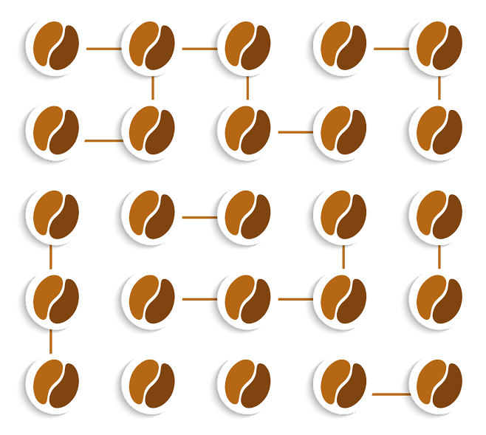
The container gets its instructions on what objects to instantiate, configure, and assemble by reading the configuration metadata provided. The configuration metadata can be represented either by XML, Java annotations, or Java code. The following diagram represents a high-level view of how Spring works. The Spring IoC container makes use of Java POJO classes and configuration metadata to produce a fully configured and executable system or application.
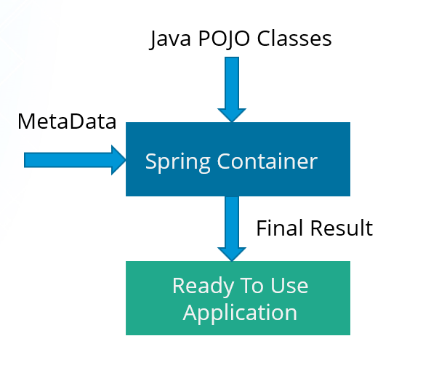
There are two types of IoC containers:
- BeanFactory
- ApplicationContext
- BeanFactory
- It is an interface defined in org.springframework.beans.factory.BeanFactory.
- Bean Factory provides the basic support for Dependency Injection.
- It is based on factory design pattern which creates the beans of any type.
- BeanFactory follows lazy-initialization technique which means beans are loaded as soon as bean factory instance is created but the beans are created only when getBean() method is called.
- The XmlBeanFactory is the implementation class for the BeanFactory interface. To use the BeanFactory, you need to create the instance of XmlBeanFactory class as shown below:
BeanFactory beanFactory = new XmlBeanFactory(new ClassPathResource("beans.xml"));

- boolean containsBean(String): returns true if the BeanFactory contains a bean
definition or bean instance that matches the given name
- Object getBean(String): Returns an instance of the bean registered under the given
name. Depending on how the bean was configured by the BeanFactory configuration,
either a singleton and thus shared instance or a newly created bean will be returned. A BeansException will be thrown when either the bean could not be found (in which case
it’ll be a NoSuchBeanDefinitionException), or an exception occurred while instantiating
and preparing the bean
- Object getBean(String, Class): returns a bean, registered under the given name.
The bean returned will be cast to the given Class. If the bean could not be cast,
corresponding exceptions will be thrown (BeanNotOfRequiredTypeException).
Furthermore, all rules of the getBean(String) method apply (see above)
- Class getType(String name): returns the Class of the bean with the given name.
If no bean corresponding to the given name could be found, a
NoSuchBeanDefinitionException will be thrown
- boolean isSingleton(String): determines whether or not the bean definition or bean
instance registered under the given name is a singleton. If no bean corresponding to
the given name could be found, a NoSuchBeanDefinitionException will be thrown
- String[] getAliases(String): Return the aliases for the given bean name, if any were
defined in the bean definition

- ApplicationContext
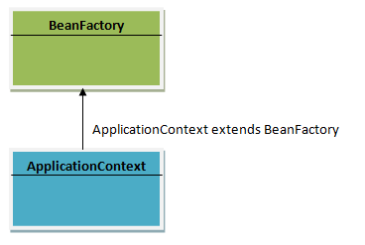
- It is an interface defined in org.springframework.context.ApplicationContext.
- It is the advanced Spring container and is built on top of the BeanFactory interface.
- ApplicationContext supports the features supported by Bean Factory but also provides some additional functionalities.
- ApplicationContext follows eager-initialization technique which means instance of beans are created as soon as you create the instance of Application context.
- The ClassPathXmlApplicationContext class is the implementation class of ApplicationContext interface. You need to instantiate the ClassPathXmlApplicationContext class to use the ApplicationContext as shown below:
ApplicationContext context=new ClassPathXmlApplicationContext("beans.xml");

Example Of BeanFactory and ApplicationContext:
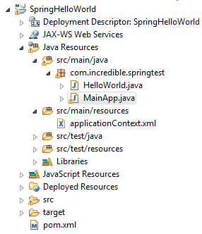
Pom.xml:
<project xmlns="http://maven.apache.org/POM/4.0.0" xmlns:xsi="http://www.w3.org/2001/XMLSchema-instance" xsi:schemaLocation="http://maven.apache.org/POM/4.0.0 http://maven.apache.org/xsd/maven-4.0.0.xsd">
<modelVersion>4.0.0</modelVersion>
<groupId>com.incredible.springtest</groupId>
<artifactId>SpringHelloWorld</artifactId>
<version>0.0.1-SNAPSHOT</version>
<packaging>war</packaging>
<properties>
<java-version>1.8</java-version>
<spring-version>4.2.3.RELEASE</spring-version>
</properties>
<dependencies>
<dependency>
<groupId>org.springframework</groupId>
<artifactId>spring-context</artifactId>
<version>${spring-version}</version>
</dependency>

<dependency>
<groupId>org.springframework</groupId>
<artifactId>spring-context-support</artifactId>
<version>${spring-version}</version>
</dependency>

<dependency>
<groupId>org.springframework</groupId>
<artifactId>spring-core</artifactId>
<version>${spring-version}</version>
</dependency>

<dependency>
<groupId>org.springframework</groupId>
<artifactId>spring-expression</artifactId>
<version>${spring-version}</version>
</dependency>
</dependencies>
</project>
applicationContext.xml:
<?xml version="1.0" encoding="UTF-8"?>
<beans xmlns="http://www.springframework.org/schema/beans"
xmlns:xsi="http://www.w3.org/2001/XMLSchema-instance"
xsi:schemaLocation="http://www.springframework.org/schema/beans
http://www.springframework.org/schema/beans/spring-beans-3.0.xsd">
<bean id="helloWorld" class="com.incredible.springtest.HelloWorld">
<property name="message" value="Hello World!" />
</bean>
</beans>

HelloWorld.java:
package com.incredible.springtest;

public class HelloWorld {

private String message;

public void setMessage(String message) {
this.message = message;
}

public void getMessage() {
System.out.println("Your Message : " + message);
}

}

MainApp.java:
package com.incredible.springtest;

import org.springframework.beans.factory.BeanFactory;
import org.springframework.beans.factory.xml.XmlBeanFactory;
import org.springframework.context.ApplicationContext;
import org.springframework.context.support.ClassPathXmlApplicationContext;
import org.springframework.core.io.ClassPathResource;

public class MainApp {
public static void main(String[] args) {

BeanFactory factory = new XmlBeanFactory(new ClassPathResource("applicationContext.xml"));

ApplicationContext context = new ClassPathXmlApplicationContext("applicationContext.xml");

HelloWorld factoryObj = (HelloWorld) factory.getBean("helloWorld");

factoryObj.getMessage();

HelloWorld contextObj = (HelloWorld) context.getBean("helloWorld");

contextObj.getMessage();
}
}
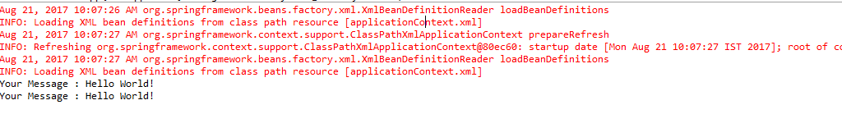
The most commonly used ApplicationContext implementations are:

- FileSystemXmlApplicationContext: This container loads the definitions of the
beans from an XML file. Here you need to provide the full path of the XML bean
configuration file to the constructor.

- ClassPathXmlApplicationContext: This container loads the definitions of the
beans from an XML file. Here you do not need to provide the full path of the XML
file but you need to set CLASSPATH properly because this container will look like
bean configuration XML file in CLASSPATH.

- WebXmlApplicationContext: This container loads the XML file with definitions
of all beans from within a web application.

- You can configure your beans in the Spring IoC container through XML files, properties files, annotations, or even APIs.
- Container reads these beans by using BeanFactory (or ApplicationContext)
- Let’s say you define the beans in XML file, say applicationcontext.xml.
- Now BeanFactory has to read applicationcontext.xml to load the beans in container.
- For this BeanFactory needs an interface that can provide the xml file o BeanFactory.
- This interface called resource object.
Sample:
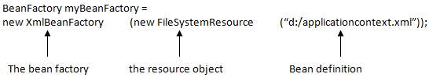
In case of ApplicationContext, the resource object is implemented internally, so as use we don’t need of resource object.
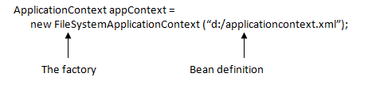
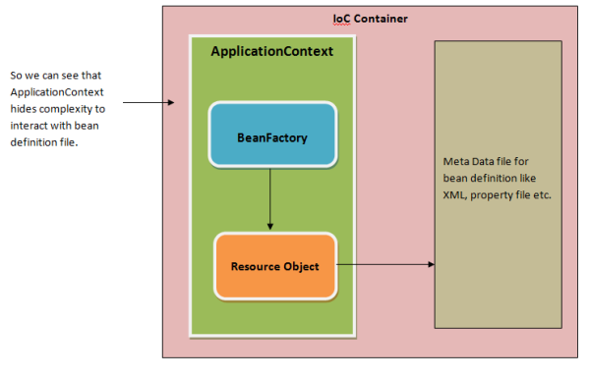

- Difference Between BeanFactory and ApplicationContext
Sr NO | BeanFactory | ApplicationContext
1 | Basic IOC | Advanced IOC
2 | Lazy Initialization | Eagar Initialization
3 | Creates a Singleton bean only when it is requested | Creates all singleton beans at the time of its own initialization
4 | Uses explicit Resource | Creates and Manages resource objects of its own
5 | No support to i18N | Supports i18N
6 | No Annotation based DI | Supports Annotation based DI
7 | Event Listeners and Event Handling NOT supported | Event Listeners and Event Handling supported
8 | No Message Resource access | Can access Message Resource
9 | Only 1 .xml file | More than 1 config or xml file
10 | No JNDI/remoting | Supports JNDI,remoting,EJB
11 | Most popular implementation of BeanFactory interface is XMLBeanFactory | Most popular implementation of ApplicationContext interface is ClassPathXmlApplicationContext
- Spring Bean Definition :
In spring the beans are managed by Spring IoC container, these are backbone of the application. You can instantiate and manage them in your application using configurations. In xml based spring bean configurations, using <bean> tag, you can manage them. Here we have given complete list of bean tag properties:
Bean definition contains the information called configuration metadata, which is needed for the container to know the following:
- How to create a bean
- Bean's lifecycle details
- Bean's dependencies
- name / id: This attribute specifies the bean unique identifier. In XML based configuration metadata, you use the id and/or name attributes to specify the bean identifier.
- class: This attribute is mandatory and specify the bean class to be used to create the bean. You should specify fully qualified class name. Include package name.
- scope: This attribute specifies the scope of the objects created from a particular bean definition. The scope values can be prototype, singleton, request, session, and global session.
- constructor-arg: This is used to inject the dependencies through bean constructor.
- properties: This attribute is used to inject the dependencies through setter method.
- autowiring mode: This is used to inject the dependencies. Modes : no,byname,byType,constructor,autodetect
- lazy-init (lazy-initialization mode): A lazy-initialized bean tells the IOC container to create a bean instance when it is first requested, rather than at startup.
- init-method (initialization method): A callback to be called just after all necessary properties on the bean have been set by the container. This is part of bean lifecycle.
- destroy-method (destruction method): A callback to be used when the container containing the bean is destroyed. This is part of bean lifecycle.
- Spring Configuration Metadata

Spring IoC container is totally decoupled from the format in which this configuration
metadata is actually written. Following are the three important methods to provide
Configuration metadata to the Spring Container:
- XML-based configuration file
- Annotation-based configuration
- Java-based configuration

Example:
<?xml version="1.0" encoding="UTF-8"?>
<beans xmlns="http://www.springframework.org/schema/beans"
xmlns:xsi="http://www.w3.org/2001/XMLSchema-instance"
xsi:schemaLocation="http://www.springframework.org/schema/beans
http://www.springframework.org/schema/beans/spring-beans-3.0.xsd">
<!-- A simple bean definition -->
<bean id="..." class="...">
<!-- collaborators and configuration for this bean go here -->
</bean>
<!-- A bean definition with lazy init set on -->
<bean id="..." class="..." lazy-init="true">
<!-- collaborators and configuration for this bean go here -->
</bean>
<!-- A bean definition with initialization method -->
<bean id="..." class="..." init-method="...">
<!-- collaborators and configuration for this bean go here -->
</bean>
<!-- A bean definition with destruction method -->
<bean id="..." class="..." destroy-method="...">
<!-- collaborators and configuration for this bean go here -->
</bean>
<!-- more bean definitions go here -->
</beans>
- Spring Bean Scopes :
When defining a <bean> in Spring, you have the option of declaring a scope for that bean. For example, to force Spring to produce a new bean instance each time one is needed, you should declare the bean's scope attribute to be prototype. Similarly, if you want Spring to return the same bean instance each time one is needed, you should declare the bean's scope attribute to be singleton.
The Spring Framework supports the following five scopes, three of which are available only if you use a web-aware ApplicationContext.

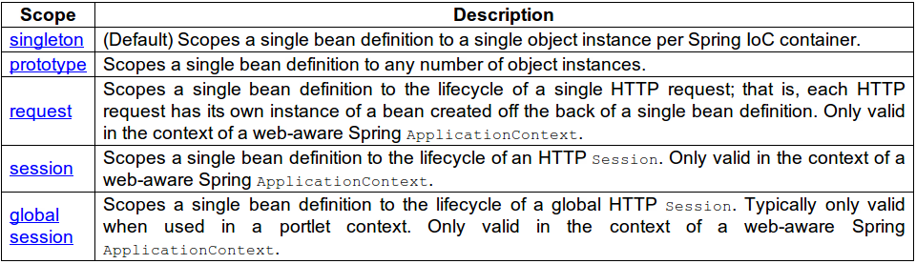
- Singleton :
If a scope is set to singleton, the Spring IoC container creates exactly one instance of the object defined by that bean definition. This single instance is stored in a cache of such singleton beans, and all subsequent requests and references for that named bean return the cached object.
The default scope is always singleton. However, when you need one and only one instance of a bean, you can set the scope property to singleton in the bean configuration file, as shown in the following code snippet:

<! -- A bean definition with singleton scope -->
<bean id="..." class="..." scope="singleton">
</bean>
Using Annotation for Bean Scope:
@Service
@Scope("singleton")
public class Point
{
private int x;
private int y;

public void setX(int x){
this.x = x;
}

public void setY(int y){
this.y = y;
}
}
Example:
HelloWorld.java:
package com.incredible.springtest;

public class HelloWorld {

private String message;

public void setMessage(String message) {
this.message = message;
}

public void getMessage() {
System.out.println("Your Message : " + message);
}

}

applicationContext.xml:
<?xml version="1.0" encoding="UTF-8"?>
<beans xmlns="http://www.springframework.org/schema/beans"
xmlns:xsi="http://www.w3.org/2001/XMLSchema-instance"
xsi:schemaLocation="http://www.springframework.org/schema/beans
http://www.springframework.org/schema/beans/spring-beans-3.0.xsd">
<bean id="helloWorld" class="com.incredible.springtest.HelloWorld" scope="singleton">
</bean>
</beans>
MainApp.java:
package com.incredible.springtest;

import org.springframework.context.ApplicationContext;
import org.springframework.context.support.ClassPathXmlApplicationContext;

public class MainApp {
public static void main(String[] args) {
ApplicationContext context = new ClassPathXmlApplicationContext("applicationContext.xml");
HelloWorld objA = (HelloWorld) context.getBean("helloWorld");

objA.setMessage("I'm object A");
objA.getMessage();

HelloWorld objB = (HelloWorld) context.getBean("helloWorld");
objB.getMessage();
}
}
Output:
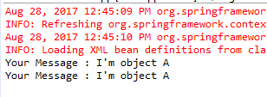

NOTE: This singleton is differ from the singleton pattern in Java Class. Single pattern in java mean you can create the only one instance of a that class in JVM. But In spring singleton bean scope means every container can create only single bean in the Spring IoC Container but a JVM can have multiple Spring IoC Container so JVM can multiple beans rather than bean singleton bean scope.
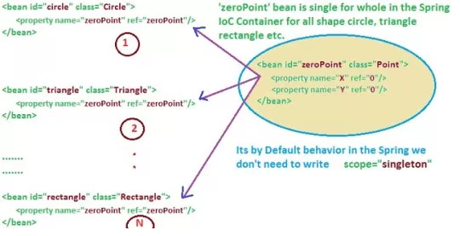
- Prototype :
If the scope is set to prototype, the Spring IoC container creates a new bean instance of the object every time a request for that specific bean is made. As a rule, use the prototype scope for all state-full beans and the singleton scope for stateless beans.

To define a prototype scope, you can set the scope property to prototype in the bean
configuration file, as shown in the following code snippet:

<!-- A bean definition with prototype scope -->
<bean id="..." class="..." scope="prototype">
</bean>
Using Annotation for Bean Scope:
@Service
@Scope("prototype")
public class Point
{
private int x;
private int y;

public void setX(int x){
this.x = x;
}

public void setY(int y){
this.y = y;
}
}

Example:
HelloWorld.java:
package com.incredible.springtest;

public class HelloWorld {

private String message;

public void setMessage(String message) {
this.message = message;
}

public void getMessage() {
System.out.println("Your Message : " + message);
}

}

applicationContext.xml:

<?xml version="1.0" encoding="UTF-8"?>
<beans xmlns="http://www.springframework.org/schema/beans"
xmlns:xsi="http://www.w3.org/2001/XMLSchema-instance"
xsi:schemaLocation="http://www.springframework.org/schema/beans
http://www.springframework.org/schema/beans/spring-beans-3.0.xsd">
<bean id="helloWorld" class="com.incredible.springtest.HelloWorld" scope="prototype">
</bean>
</beans>
MainApp.java:
package com.incredible.springtest;

import org.springframework.context.ApplicationContext;
import org.springframework.context.support.ClassPathXmlApplicationContext;

public class MainApp {
public static void main(String[] args) {
ApplicationContext context = new ClassPathXmlApplicationContext("applicationContext.xml");
HelloWorld objA = (HelloWorld) context.getBean("helloWorld");

objA.setMessage("I'm object A");
objA.getMessage();

HelloWorld objB = (HelloWorld) context.getBean("helloWorld");
objB.getMessage();
}
}

Output:
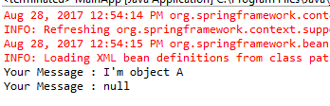
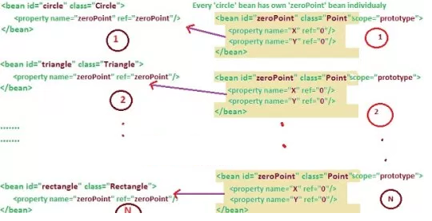
- Request :
This scopes a bean definition to an HTTP request. Only valid in the context of a web-aware Spring ApplicationContext.
<bean class="com.dineshonjava.Point" id="point" scope="request"></bean>
- Session:
This scopes a bean definition to an HTTP session. Only valid in the context of a web-aware Spring ApplicationContext.
<bean class="com.dineshonjava.Point" id="point" scope="session"></bean>
- global-session:
This scopes a bean definition to a global HTTP session. Only valid in the context of a web-aware Spring ApplicationContext.
<bean class="com.dineshonjava.Point" id="point" scope="globalSession"></bean>

- Spring Bean Life Cycle :
Spring Beans are Instantiated / Managed by Spring IoC Container. These beans can be created by providing bean specific configuration metadata to container. Configuration Metadata can be provided in any of below formats.
1. XML
2. Annotation
3. Java Code
When bean is initialized it might require to perform some activity before it can come into use able state (State in which application can use it) and when bean is getting destroyed there might be some cleanup activity required for given bean. These activities are known as bean Lifecycle.
Standard bean lifecycle interfaces & there standard order of execution are given below.
1 IoC container will look for the configuration metadata of given Bean.
2 Once find, container will create the instance of Bean (Using reflection API).
3 After instance creation dependency will be injected (DI).
If Bean Class implements any of the below highlighted interface then corresponding method will be invoked in below order(Point 4 – 13).
4 setBeanName method of BeanNameAware Interface. It sets the name of the bean in the bean factory that created this bean.
5 setBeanClassLoader method of BeanClassLoaderAware Interface. Callback that supplies the bean to a bean instance.
6 setBeanFactory method of BeanFactoryAware Interface. Callback that supplies the owning factory to a bean instance.
Below method execution will be applicable when running in an application context. (Points 7 – 11)
7 setResourceLoader method of ResourceLoaderAware Interface. It set the ResourceLoader that this object runs in.
8 setApplicationEventPublisher method of ApplicationEventPublisherAware Interface. Set the ApplicationEventPublisher that this object runs in.
9 setMessageSource method of MessageSourceAware Interface. Set the MessageSource that this object runs in.
10 setApplicationContext method of ApplicationContextAware Interface. Set the ApplicationContext that this object runs in.
11 setServletContext method of ServletContextAware Interface. Set the ServletContext that this object runs in.
12 postProcessBeforeInitialization method of BeanPostProcessorInterface. Apply this BeanPostProcessor to the given new bean instance before any bean initialization callbacks.
13 afterPropertiesSet method of InitializingBean Interface. Invoked by a BeanFactory after it has set all bean properties supplied.
In case Bean class has custom init method defined(via init-method attribute)
14 Custom init method will be invoked.
15 postProcessAfterInitialization methods of BeanPostProcessors. Apply this BeanPostProcessor to the given new bean instance after any bean initialization callbacks
When Bean Factory is getting shut down following lifecycle methods will be executed.
1- DisposableBean’s destroy method. Invoked by a BeanFactory on destruction of a singleton.
2- Custom destroy method will be executed if there is any defined via destroy-method attributes
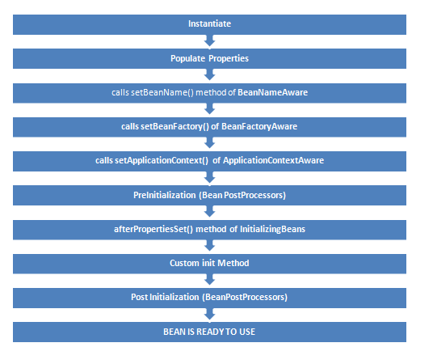

- InitializingBean and DisposbleBean callback interfaces
InitalizingBean interface is defined under org.springframework.beans.factory package and declares a single method where it can be used to add any initialization related code. Any bean implementing InitalizingBean needs to provide an implementation of afterPropertiesSet() method. Signature of method is:
void afterPropertiesSet() throws Exception;
Similarly DisposableBean interface is defined under the org.springframework.beans.factory and declares a single method which gets executed when bean is destroyed and can be used to add any cleanup related code. Any bean implementing DisposableBean needs to provide an implementation of destroy() method. Signature of method is :
void destroy() throws Exception;
Example :
PersonBean.java:
package com.incredible.springbean.lifecycle;
import org.springframework.beans.factory.DisposableBean;
import org.springframework.beans.factory.InitializingBean;

public class PersonBean implements InitializingBean, DisposableBean {

private String name;

public PersonBean() {
System.out.println("Constructor of person bean is called !! ");
}

public void destroy() throws Exception {
System.out.println("destroy method of person bean is called !! ");
}

public void afterPropertiesSet() throws Exception {
System.out.println("afterPropertiesSet method of person bean is called !! ");
}

public String getName() {
return name;
}

public void setName(String name) {
this.name = name;
}
}
applicationContext.xml:
<?xml version="1.0" encoding="UTF-8"?>
<beans xmlns="http://www.springframework.org/schema/beans"
xmlns:xsi="http://www.w3.org/2001/XMLSchema-instance"
xsi:schemaLocation="http://www.springframework.org/schema/beans
http://www.springframework.org/schema/beans/spring-beans-3.0.xsd">
<bean id="personBean" class="com.incredible.springbean.lifecycle.PersonBean">
<property name="name" value="Dummy Person" />
</bean>
</beans>
TestPersonBean.java:
package com.incredible.springbean.lifecycle;
import org.springframework.context.ApplicationContext;
import org.springframework.context.support.AbstractApplicationContext;
import org.springframework.context.support.ClassPathXmlApplicationContext;
public class TestPersonBean {
public static void main(String[] args) {

ApplicationContext context = new ClassPathXmlApplicationContext("applicationContext.xml");
PersonBean bean = (PersonBean)context.getBean("personBean");
System.out.println(bean.getName());
((AbstractApplicationContext) context).registerShutdownHook();
}
}
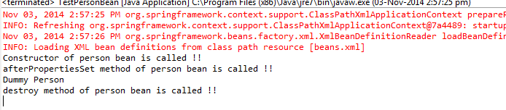
- Bean Name, Factory, Application context Aware interfaces
Several times functionality requires infrastructure or we can say application context information in a bean. To achieve such functionalities, Spring framework provides a range of Aware interfaces each interface requires us to implement a method to inject the dependency in bean. Most commonly used are –
- BeanFactoryAware - This interface provides setBeanFactory() method that supplies the owning bean factory instance to the bean. Signature of the method is
void setBeanFactory(BeanFactory beanFactory) throws BeansException
- BeanNameAware - This interface provides setBeanName() method which sets the name of the bean in the bean factory that created this bean. Signature of the method is-
void setBeanName(String name);
- ApplicationContextAware -This interface provides setApplicationContext() method that supplies the owning application context instance to the bean. Signature of the method is
void setApplicationContext(ApplicationContext applicationContext) throws BeansException
Example:
AwareBean.java:
package com.incredible.springbean.lifecycle;

import java.util.Arrays;
import org.springframework.beans.BeansException;
import org.springframework.beans.factory.BeanFactory;
import org.springframework.beans.factory.BeanFactoryAware;
import org.springframework.beans.factory.BeanNameAware;
import org.springframework.context.ApplicationContext;
import org.springframework.context.ApplicationContextAware;

public class AwareBean implements ApplicationContextAware, BeanNameAware, BeanFactoryAware {
public void setBeanFactory(BeanFactory beanFactory) throws BeansException {
System.out.println("setBeanFactory method of Aware bean is called");
System.out.println("setBeanFactory:: Aware bean singleton=" + beanFactory.isSingleton("awareBean"));
}

public void setBeanName(String beanName) {
System.out.println("setBeanName method of Aware bean is called");
System.out.println("setBeanName:: Bean Name defined in context=" + beanName);
}

public void setApplicationContext(ApplicationContext applicationContext) throws BeansException {
System.out.println("setApplicationContext method of Aware bean is called");
System.out.println("setApplicationContext:: Bean Definition Names="
+ Arrays.toString(applicationContext.getBeanDefinitionNames()));
}
}

applicationContext.xml:

<?xml version="1.0" encoding="UTF-8"?>
<beans xmlns="http://www.springframework.org/schema/beans"
xmlns:xsi="http://www.w3.org/2001/XMLSchema-instance"
xsi:schemaLocation="http://www.springframework.org/schema/beans
http://www.springframework.org/schema/beans/spring-beans-3.0.xsd">
<bean id="awareBean" class="com.incredible.springbean.lifecycle.AwareBean" >
</bean>
</beans>
TestAwareBean.java:
package com.incredible.springbean.lifecycle;

import org.springframework.context.ApplicationContext;
import org.springframework.context.support.AbstractApplicationContext;
import org.springframework.context.support.ClassPathXmlApplicationContext;

public class TestAwareBean {
public static void main(String[] args) {

ApplicationContext context = new ClassPathXmlApplicationContext("applicationContext.xml");
AwareBean bean = (AwareBean) context.getBean("awareBean");
((AbstractApplicationContext) context).registerShutdownHook();
}
}
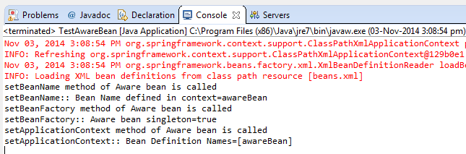

- Custom init() and destroy() methods in bean configuration file
Implementing InitalizingBean and DisposableBean interface is simple to use but create tight coupling with the Spring framework in our bean implementations.
Alternatively we can init-method and destroy-method attribute values for the bean in the spring bean configuration file. This is the recommended approach because of no direct dependency to spring framework and we can create our own methods.
Note: Both post-init and pre-destroy methods should have no arguments but they can throw Exceptions
<beans>
<bean id="bean_id" class="bean.class"
init-method="customInitmethod"
destroy-method="customDestroymethod">
</bean>
</beans>

We can configure the default init-method and destroy-method which will be applied on all the beans .They are useful when we have a pattern of defining common method names such as init() and destroy() for all your beans consistently.
<beans default-init-method=”customDefaultInitMethod” default-destroy-method=”customDefaultDestroyMethod” >
<bean id="bean_id" class="bean.class" >
</bean>
</beans>

Example:
CustomLifeCycleMethodBean.java:
package com.incredible.springbean.lifecycle;

public class CustomLifeCycleMethodBean {
private String name;

public CustomLifeCycleMethodBean()
{
System.out.println("Constructor of bean is called !! ");
}

public void customDestroy() throws Exception {

System.out.println("custom destroy method of bean is called !! ");
}

public void customInit() throws Exception {
System.out.println("custom Init method of bean is called !! ");
}

public String getName() {
return name;
}

public void setName(String name) {
this.name = name;
}

}
applicationContext.xml:
<?xml version="1.0" encoding="UTF-8"?>
<beans xmlns="http://www.springframework.org/schema/beans"
xmlns:xsi="http://www.w3.org/2001/XMLSchema-instance"
xsi:schemaLocation="http://www.springframework.org/schema/beans
http://www.springframework.org/schema/beans/spring-beans-3.0.xsd">
<bean id="customLifeCycleMethodBean"
class="com.incredible.springbean.lifecycle.CustomLifeCycleMethodBean"
init-method="customInit"
destroy-method="customDestroy">
<property name="name" value="custom methods bean" ></property>
</bean>
</beans>
TestCustomMethodLifeCycleBean.java:
package com.incredible.springbean.lifecycle;

import org.springframework.context.ApplicationContext;
import org.springframework.context.support.AbstractApplicationContext;
import org.springframework.context.support.ClassPathXmlApplicationContext;

public class TestCustomMethodLifeCycleBean {
public static void main(String[] args) {

ApplicationContext context =
new ClassPathXmlApplicationContext("applicationContext.xml");

CustomLifeCycleMethodBean bean = (CustomLifeCycleMethodBean)context.getBean("customLifeCycleMethodBean");
((AbstractApplicationContext) context).registerShutdownHook();
}
}
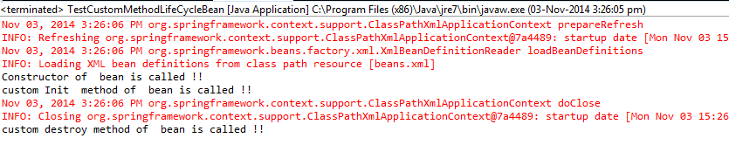
- Global init and destroy methods
Example :
CustomGlobalLifeCycleMehodBean.java:
package com.incredible.springbean.lifecycle;

public class CustomGlobalLifeCycleMehodBean {
public CustomGlobalLifeCycleMehodBean()
{
System.out.println("Constructor of bean is called !! ");
}
public void globalCustomDestroy() throws Exception {
System.out.println("global custom destroy method of bean is called !! ");
}
public void globalCustomInit() throws Exception {
System.out.println("global custom Init method of bean is called !! ");
}
}
applicationContext.xml:
<?xml version="1.0" encoding="UTF-8"?>
<beans xmlns="http://www.springframework.org/schema/beans"
xmlns:xsi="http://www.w3.org/2001/XMLSchema-instance"
xsi:schemaLocation="http://www.springframework.org/schema/beans
http://www.springframework.org/schema/beans/spring-beans-3.0.xsd"
default-init-method="globalCustomInit"
default-destroy-method="globalCustomDestroy">
<bean id="customGlobalLifeCycleMethodBean"
class="com.incredible.springbean.lifecycle.CustomGlobalLifeCycleMehodBean" />
</beans>
TestCustomGlobalMethodLifeCycleBean.java
package com.incredible.springbean.lifecycle;

import org.springframework.context.ApplicationContext;
import org.springframework.context.support.AbstractApplicationContext;
import org.springframework.context.support.ClassPathXmlApplicationContext;

public class TestCustomGlobalMethodLifeCycleBean {
public static void main(String[] args) {

ApplicationContext context =
new ClassPathXmlApplicationContext("applicationContext.xml");
CustomGlobalLifeCycleMehodBean bean = (CustomGlobalLifeCycleMehodBean)context.getBean("customGlobalLifeCycleMethodBean");
((AbstractApplicationContext) context).registerShutdownHook();
}
}
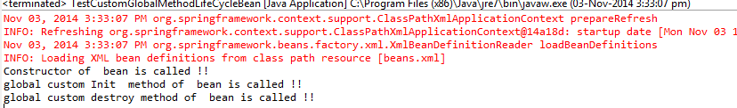

- Spring Bean Post Processors:
The BeanPostProcessor interface defines callback methods that you can implement to provide your own instantiation logic, dependency-resolution logic, etc. You can also implement some custom logic after the Spring container finishes instantiating, configuring,and initializing a bean by plugging in one or more BeanPostProcessor implementations.

You can configure multiple BeanPostProcessor interfaces and you can control the order in which these BeanPostProcessor interfaces execute by setting the order property provided the BeanPostProcessor implements the Ordered interface.

The BeanPostProcessors operate on bean (or object) instances, which means that the Spring IoC container instantiates a bean instance and then BeanPostProcessor interfaces do their work.

An ApplicationContext automatically detects any beans that are defined with the
implementation of the BeanPostProcessor interface and registers these beans as postprocessors,to be then called appropriately by the container upon bean creation.

Example:

HelloWorld.java
package com.incredible.springbean.lifecycle;

public class HelloWorld {
private String message;

public void setMessage(String message) {
this.message = message;
}

public void getMessage() {
System.out.println("Your Message : " + message);
}

public void init() {
System.out.println("Bean is going through init.");
}

public void destroy() {
System.out.println("Bean will destroy now.");
}
}

InitHelloWorld.java

package com.incredible.springbean.lifecycle;
import org.springframework.beans.factory.config.BeanPostProcessor;
import org.springframework.beans.BeansException;

public class InitHelloWorld implements BeanPostProcessor {
public Object postProcessBeforeInitialization(Object bean, String beanName) throws BeansException {
System.out.println("BeforeInitialization : " + beanName);
return bean; // you can return any other object as well
}

public Object postProcessAfterInitialization(Object bean, String beanName) throws BeansException {
System.out.println("AfterInitialization : " + beanName);
return bean; // you can return any other object as well
}
}

applicationContext.xml:
<?xml version="1.0" encoding="UTF-8"?>
<beans xmlns="http://www.springframework.org/schema/beans"
xmlns:xsi="http://www.w3.org/2001/XMLSchema-instance"
xsi:schemaLocation="http://www.springframework.org/schema/beans
http://www.springframework.org/schema/beans/spring-beans-3.0.xsd">

<bean id="helloWorld" class="com.incredible.springbean.lifecycle.HelloWorld"
init-method="init" destroy-method="destroy">
<property name="message" value="Hello World!" />
</bean>
<bean class="com.incredible.springbean.lifecycle.InitHelloWorld" />

</beans>

TestPostProcessors.java:
package com.incredible.springbean.lifecycle;
import org.springframework.context.support.AbstractApplicationContext;
import org.springframework.context.support.ClassPathXmlApplicationContext;

public class TestPostProcessors {
public static void main(String[] args) {
AbstractApplicationContext context = new ClassPathXmlApplicationContext("applicationContext.xml");
HelloWorld obj = (HelloWorld) context.getBean("helloWorld");
obj.getMessage();
context.registerShutdownHook();
}
}
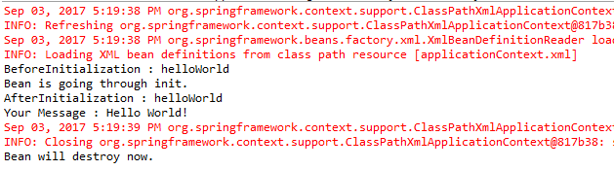

- Spring Bean Inheritance:
In general Inheritance is a mechanism in which one object acquires all the properties and behaviors of parent object. With inheritance, we can create new classes that are built upon existing classes. When we inherit from an existing class, we can reuse methods and fields of parent class, and can add new methods and fields also.
Similarly Spring framework provides out of the box support of inheritance for beans defined in beans in a xml file (beans configuration file). A child bean definition inherits configuration data from a parent definition and the child definition can override some values, or add others, as needed. Conceptually beans configuration inheritance is similar to the java inheritance.

Spring Bean Inheritance Ways
  - A bean in a xml file can extend other bean using parent attribute in bean tag.
<bean id="parent_bean” class="class_name”/>
<bean id="child_bean” parent="parent_bean’/>
In this case we need not to define class attribute in children bean
Example:
ParentBean.java:
package com.incredible.springbean.inheritance;

public class ParentBean {
private String message;
private String title;

public String getTitle() {
return title;
}

public void setTitle(String title) {
this.title = title;
}

public String getMessage() {
return message;
}

public void setMessage(String message) {
this.message = message;
}
}
applicationContext.xml:
Define bean entry of ParentBean and ChildBean. ParentBean will set message property and ChildBean will have a parent attribute and will have set title property.
<?xml version="1.0" encoding="UTF-8"?>
<beans xmlns="http://www.springframework.org/schema/beans"
xmlns:xsi="http://www.w3.org/2001/XMLSchema-instance"
xsi:schemaLocation="http://www.springframework.org/schema/beans
http://www.springframework.org/schema/beans/spring-beans-3.0.xsd">

<bean id="parentBean" class="com.incredible.springbean.inheritance.ParentBean" >
<property name="message" value="Test Message by Parent bean ">
</property>
</bean>

<bean id="childBean" parent="parentBean" >
<property name="title" value="Title by Child Bean ">
</property>
</bean>
</beans>
TestInheritance.java:
package com.incredible.springbean.inheritance;

import org.springframework.context.ApplicationContext;
import org.springframework.context.support.AbstractApplicationContext;
import org.springframework.context.support.ClassPathXmlApplicationContext;
public class TestInheritance {
public static void main(String[] args) {
ApplicationContext context =
new ClassPathXmlApplicationContext("applicationContext.xml");
ParentBean parentBean = (ParentBean)context.getBean("parentBean");
System.out.println("=====Parent Bean====");
System.out.println("Message ::" + parentBean.getMessage());
System.out.println("Title ::" + parentBean.getTitle());
ParentBean childrenBean = (ParentBean)context.getBean("childBean");
System.out.println("=====Child Bean====");
System.out.println("Message ::" + childrenBean.getMessage());
System.out.println("Title ::" + childrenBean.getTitle());
((AbstractApplicationContext) context).registerShutdownHook();
}
}
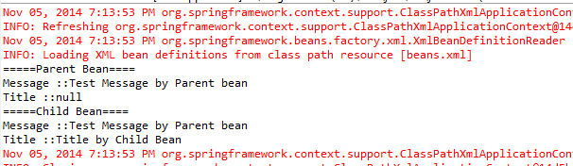
Change the above program to demonstrate overriding
Solution – Overriding means redefine the property or methods. Let’s change the bean.xml file for child tag to set the message field as well (refer below)
<?xml version="1.0" encoding="UTF-8"?>
<beans xmlns="http://www.springframework.org/schema/beans"
xmlns:xsi="http://www.w3.org/2001/XMLSchema-instance"
xsi:schemaLocation="http://www.springframework.org/schema/beans
http://www.springframework.org/schema/beans/spring-beans-3.0.xsd">

<bean id="parentBean" class="com.incredible.springbean.inheritance.ParentBean" >
<property name="message" value="Test Message by Parent bean ">
</property>
</bean>

<bean id="childBean" parent="parentBean" >
<property name="title" value="Title by Child Bean ">
</property>
<property name="message" value="Test Message by Child bean ">
</property>
</bean>
</beans>
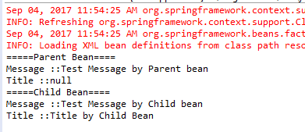

Inheritance using abstract (Define parent bean as abstract)
We can define the parent class as abstract like below
<bean id="parent_bean" class="class_name" abstract=”true”/>
<bean id="child_bean" parent="parent_bean"/>

In this case we parent class will be considered as abstract and we will not be able to call getBean() method on parent bean (as object of abstract class cannot be created) .
Note: adding abstract as true does not mean we will make out java class as abstract.
Example:
ParentBean.java:
package com.incredible.springbean.inheritance;

public class ParentBean {
private String message;
private String title;

public String getTitle() {
return title;
}

public void setTitle(String title) {
this.title = title;
}

public String getMessage() {
return message;
}

public void setMessage(String message) {
this.message = message;
}
}
applicationContext.xml:
<?xml version="1.0" encoding="UTF-8"?>
<beans xmlns="http://www.springframework.org/schema/beans"
xmlns:xsi="http://www.w3.org/2001/XMLSchema-instance"
xsi:schemaLocation="http://www.springframework.org/schema/beans
http://www.springframework.org/schema/beans/spring-beans-3.0.xsd">

<bean id="parentBean" class="com.incredible.springbean.inheritance.ParentBean" abstract="true">
<property name="message" value="Test Message by Parent bean ">
</property>
</bean>

<bean id="childBean" parent="parentBean" >
<property name="title" value="Title by Child Bean ">
</property>
</bean>
</beans>
TestAbstractInheritance.java:
package com.incredible.springbean.inheritance;

import org.springframework.context.ApplicationContext;
import org.springframework.context.support.AbstractApplicationContext;
import org.springframework.context.support.ClassPathXmlApplicationContext;
public class TestAbstractInheritance {
public static void main(String[] args) {
ApplicationContext context =
new ClassPathXmlApplicationContext("applicationContext.xml");
ParentBean childrenBean = (ParentBean)context.getBean("childBean");
System.out.println("=====Child Bean====");
System.out.println("Message ::" + childrenBean.getMessage());
System.out.println("Title ::" + childrenBean.getTitle());
((AbstractApplicationContext) context).registerShutdownHook();
}
}
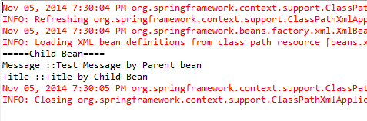
Try to create a bean of AbstractParentBean and see what happens
ParentBean parentBean= (ParentBean)context.getBean("parentBean");

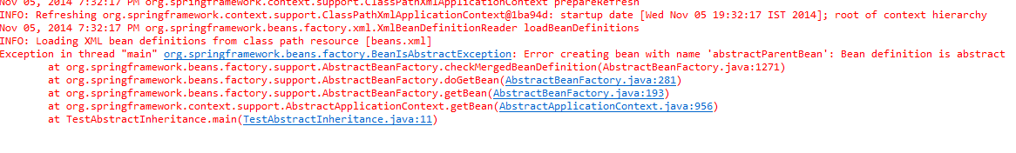

Define parent class as template –
Sometimes we have got several beans and they have some common fields in them. In such scenario, we can define parent class as template. In such case, parent bean does not need a “class” attribute, instead defines in child beans.
<bean id=”parent_bean” abstract=”true”/>
<bean id=”child_bean” parent=”parent_bean” class=”class_name” />

Example:
ParentBean.java:
package com.incredible.springbean.inheritance;

public class ParentBean {
private String message;
private String title;

public String getTitle() {
return title;
}

public void setTitle(String title) {
this.title = title;
}

public String getMessage() {
return message;
}

public void setMessage(String message) {
this.message = message;
}
}

applicationContext.xml:
<?xml version="1.0" encoding="UTF-8"?>
<beans xmlns="http://www.springframework.org/schema/beans"
xmlns:xsi="http://www.w3.org/2001/XMLSchema-instance"
xsi:schemaLocation="http://www.springframework.org/schema/beans
http://www.springframework.org/schema/beans/spring-beans-3.0.xsd">

<bean id="templateParentBean" abstract="true">
<property name="message" value="Test Message by Parent bean ">
</property>
</bean>
<bean id="childBean" parent="templateParentBean" class="com.incredible.springbean.inheritance.ParentBean" >
<property name="title" value="Title by Child Bean ">
</property>
</bean>
</beans>
TestTemplateInheritance.java:
package com.incredible.springbean.inheritance;

import org.springframework.context.ApplicationContext;
import org.springframework.context.support.AbstractApplicationContext;
import org.springframework.context.support.ClassPathXmlApplicationContext;
public class TestTemplateInheritance {
public static void main(String[] args) {
ApplicationContext context =
new ClassPathXmlApplicationContext("applicationContext.xml");
ParentBean parentBean = (ParentBean)context.getBean("childBean");
System.out.println("=====Child Bean====");
System.out.println("Message ::" + parentBean.getMessage());
System.out.println("Title ::" + parentBean.getTitle());
((AbstractApplicationContext) context).registerShutdownHook();
}
}
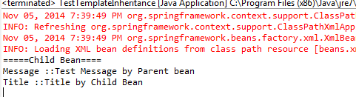

- Spring Dependency Injection(Inversion Of Control)
Every Java-based application has a few objects that work together to present what the
End-user sees as a working application. When writing a complex Java application,
application classes should be as independent as possible of other Java classes to increase the possibility to reuse these classes and to test them independently of other classes while unit testing. Dependency Injection (or sometime called wiring) helps in gluing these classes together and at the same time keeping them independent.
Consider you have an application which has a text editor component and you want to provide a spell check. Your standard code would look something like this:
public class TextEditor {
private SpellChecker spellChecker;
public TextEditor() {
spellChecker = new SpellChecker();
}
}
What we've done here is, created a dependency between the TextEditor and the SpellChecker. In an inversion of control scenario, we would instead do something like this:
public class TextEditor {
private SpellChecker spellChecker;
public TextEditor(SpellChecker spellChecker) {
this.spellChecker = spellChecker;
}
}
Here, the TextEditor should not worry about SpellChecker implementation. The SpellChecker will be implemented independently and will be provided to the TextEditor at the time of TextEditor instantiation. This entire procedure is controlled by the Spring Framework.Here, we have removed total control from the TextEditor and kept it somewhere else (i.e.XML configuration file) and the dependency (i.e. class SpellChecker) is being injected intothe class TextEditor through a Class Constructor. Thus the flow of control has been "inverted" by Dependency Injection (DI) because you have effectively delegated dependances to some external system.
The second method of injecting dependency is through Setter Methods of the TextEditor class where we will create a SpellChecker instance. This instance will be used to call setter methods to initialize TextEditor's properties.
- Constructor-based Dependency Injection :
Constructor-based DI is accomplished when the container invokes a class constructor with a number of arguments, each representing a dependency on the other class.

Example:
TextEditor.java:
package com.incredible.dependency.injection;

public class TextEditor {
private SpellChecker spellChecker;

public TextEditor(SpellChecker spellChecker) {
System.out.println("Inside TextEditor constructor.");
this.spellChecker = spellChecker;
}

public void spellCheck() {
spellChecker.checkSpelling();
}
}
SpellChecker.java:
package com.incredible.dependency.injection;

public class SpellChecker {
public SpellChecker() {
System.out.println("Inside SpellChecker constructor.");
}

public void checkSpelling() {
System.out.println("Inside checkSpelling.");
}
}
dependency.xml:
<beans xmlns="http://www.springframework.org/schema/beans"
xmlns:xsi="http://www.w3.org/2001/XMLSchema-instance"
xsi:schemaLocation="http://www.springframework.org/schema/beans
http://www.springframework.org/schema/beans/spring-beans-3.0.xsd">

<!-- Definition for textEditor bean -->
<bean id="textEditor" class="com.incredible.dependency.injection.TextEditor">
<constructor-arg ref="spellChecker" />
</bean>
<!-- Definition for spellChecker bean -->
<bean id="spellChecker" class="com.incredible.dependency.injection.SpellChecker">
</bean>
</beans>
TestConstructorDepInj.java:
package com.incredible.dependency.injection;

import org.springframework.context.ApplicationContext;
import org.springframework.context.support.ClassPathXmlApplicationContext;

public class TestConstructorDepInj {
public static void main(String[] args) {
ApplicationContext context =
new ClassPathXmlApplicationContext("dependency.xml");
TextEditor te = (TextEditor) context.getBean("textEditor");
te.spellCheck();
}

}

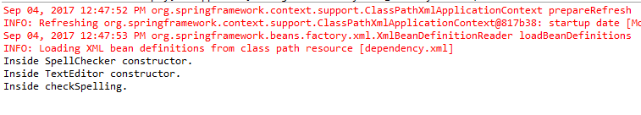

Constructor Arguments Resolution:
There may be an ambiguity while passing arguments to the constructor, in case there are more than one parameters. To resolve this ambiguity, the order in which the constructor arguments are defined in a bean definition is the order in which those arguments are supplied to the appropriate constructor

Examples:
1)
package x.y;
public class Foo {
public Foo(Bar bar, Baz baz) {
// ...
}
}

The following configuration works fine:
<beans>
<bean id="foo" class="x.y.Foo">
<constructor-arg ref="bar"/>
<constructor-arg ref="baz"/>
</bean>
<bean id="bar" class="x.y.Bar"/>
<bean id="baz" class="x.y.Baz"/>
</beans>

2)
public Foo(int year, String name) {
// ...
}
<beans>
<bean id="exampleBean" class="examples.ExampleBean">
<constructor-arg type="int" value="2001"/>
<constructor-arg type="java.lang.String" value="Zara"/>
</bean>
</beans>

3)
<beans>
<bean id="exampleBean" class="examples.ExampleBean">
<constructor-arg index="0" value="2001"/>
<constructor-arg index="1" value="Zara"/>
</bean>
</beans>

- Injecting bean references using Constructor Dependency Injection
<bean id="textEditor" class="com.incredible.dependency.injection.TextEditor">
<constructor-arg ref="spellChecker" />
</bean>
<!-- Definition for spellChecker bean -->
<bean id="spellChecker" class="com.incredible.dependency.injection.SpellChecker"></bean>
</beans>

- Setter-based Dependency Injection :
Setter-based DI is accomplished by the container calling setter methods on your beans
after invoking a no-argument constructor or no-argument static factory method to instantiate your bean.

Example:
TextEditor.java:
package com.incredible.dependency.injection;

public class TextEditor {
private SpellChecker spellChecker;

// a setter method to inject the dependency.
public void setSpellChecker(SpellChecker spellChecker) {
System.out.println("Inside setSpellChecker.");
this.spellChecker = spellChecker;
}

// a getter method to return spellChecker
public SpellChecker getSpellChecker() {
return spellChecker;
}

public void spellCheck() {
spellChecker.checkSpelling();
}
}

SpellChecker.java:
package com.incredible.dependency.injection;

public class SpellChecker {
public SpellChecker() {
System.out.println("Inside SpellChecker constructor.");
}

public void checkSpelling() {
System.out.println("Inside checkSpelling.");
}
}
dependency.xml:
<beans xmlns="http://www.springframework.org/schema/beans"
xmlns:xsi="http://www.w3.org/2001/XMLSchema-instance"
xsi:schemaLocation="http://www.springframework.org/schema/beans
http://www.springframework.org/schema/beans/spring-beans-3.0.xsd">

<!-- Definition for textEditor bean -->
<bean id="textEditor" class="com.incredible.dependency.injection.TextEditor">
<property name="spellChecker" ref="spellChecker" />
</bean>
<!-- Definition for spellChecker bean -->
<bean id="spellChecker" class="com.incredible.dependency.injection.SpellChecker">
</bean>
</beans>
TestSetterDepInj.java:
package com.incredible.dependency.injection;

import org.springframework.context.ApplicationContext;
import org.springframework.context.support.ClassPathXmlApplicationContext;

public class TestSetterDepInj {
public static void main(String[] args) {
ApplicationContext context =
new ClassPathXmlApplicationContext("dependency.xml");
TextEditor te = (TextEditor) context.getBean("textEditor");
te.spellCheck();
}

}

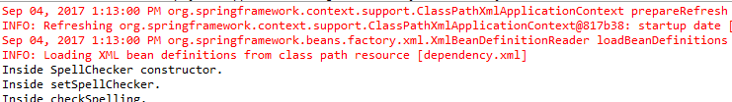

- Injecting bean references using Setter Dependency Injection
<!-- Definition for textEditor bean -->
<bean id="textEditor" class="com.incredible.dependency.injection.TextEditor">
<property name="spellChecker" ref="spellChecker" />
</bean>
<!-- Definition for spellChecker bean -->
<bean id="spellChecker" class="com.incredible.dependency.injection.SpellChecker">
</bean>
</beans>

- Below configuration will instantiate Hostel class using a default constructor and then sets the value of rooms to 30
<bean id="hostel" class="Hostel">
<property name=”rooms” value="30"/>
</bean>
- Setting value as null
We can use <null/> tag to set the value of property as null in beans configuration like: <property name="name" ><null/> </property>
- Setting blank value
We can use <value/> tag to set the value of property as blank in beans configuration like : <property name="name" ><value/> </property>
- Setting Compounded property names
We can use period (.) in the name attribute of a property tag if the property is compounded.
For example if Foo class has an instance of Bar class and Bar class has a property name then below configuration can be used.
<bean id="foo" class="Foo">
<property name=”bar.name” value="Test value "/>
</bean>

- Constructor and Setter Based Dependency Injection together:
We can use both, Constructor-based and Setter-based DI together but it is a advisable to use constructor arguments for mandatory dependencies and setters for optional dependencies.
In this strategy, object is created using the arguments constructor and then setters are called. For example in below example , object will be created using one argument constructor and then setRooms method will be invoked
public class Hostel{
private int rooms;
private int floors;

public void setRooms(int rooms){
this.rooms=rooms;
}
public Hostel(int floors){
this.floors=floors;
}
}

<bean id="hostel" class="Hostel">
<property name=”rooms” value="30"/>
<constructor-arg value="10"/>
</bean>

Example:

Student.java:
package com.incredible.dependency.injection;

public class Student {
private String name ;
public String getName() {
return name;
}
public void setName(String name) {
this.name = name;
}
}

Room.java:
package com.incredible.dependency.injection;

public class Room {
private int roomNumber;
private Student allotedTo;

public int getRoomNumber() {
return roomNumber;
}

public void setRoomNumber(int roomNumber) {
this.roomNumber = roomNumber;
}

public Room(Student allotedTo) {
this.allotedTo = allotedTo;

}

@Override
public String toString() {
return "Room [roomNumber=" + roomNumber + ", allotedTo=" + allotedTo.getName() + "]";
}
}

dependency.xml:

<beans xmlns="http://www.springframework.org/schema/beans"
xmlns:xsi="http://www.w3.org/2001/XMLSchema-instance"
xsi:schemaLocation="http://www.springframework.org/schema/beans
http://www.springframework.org/schema/beans/spring-beans-3.0.xsd">

<bean id="room" class="com.incredible.dependency.injection.Room">
<constructor-arg ref ="StudentA"/>
<property name="roomNumber" value="101"/>
</bean>
<bean id="StudentA" class="com.incredible.dependency.injection.Student" >
<property name="name" value="Amey Bhalerao"/>
</bean>
</beans>
Test.java:
package com.incredible.dependency.injection;

import org.springframework.context.ApplicationContext;
import org.springframework.context.support.ClassPathXmlApplicationContext;

public class Test {
public static void main(String[] args) {
ApplicationContext context =
new ClassPathXmlApplicationContext("dependency.xml");
Room room = (Room)context.getBean("room");
System.out.println(room);
}

}
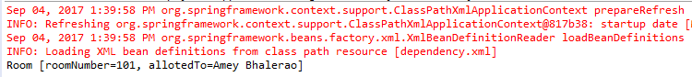
- XML Configuration using p-namespace
Our bean class can have several properties and sometimes it becomes very tedious to define several property tags (one for each property) . To address this issue , Spring has provided an alternate approach of p-namespace.
<bean id="room" class="Room">
<property name="roomNumber" value ="101"/>
<property name="allotedTo" ref ="StudentA"/>
</bean>
<bean id="StudentA" class="Student" >
<property name="name" value="joe bloggs"/>
</bean>
We can alternatively write it as
<?xml version="1.0" encoding="UTF-8"?>
<beans xmlns="http://www.springframework.org/schema/beans"
xmlns:xsi="http://www.w3.org/2001/XMLSchema-instance"
xsi:schemaLocation="http://www.springframework.org/schema/beans
http://www.springframework.org/schema/beans/spring-beans-3.0.xsd"
xmlns:p="http://www.springframework.org/schema/p">
<bean id="room" class="Room"
p:roomNumber="101"
p:allotedTo-ref="StudentA"/>
</bean>
<bean id="StudentA" class="Student" >
<property name="name" value="joe bloggs"/>
</bean>
</beans>
- Aliasing Beans :
We can introduce an alias of a bean defined in same beans configuration file. Once done the bean can be referred using alias as well.
<alias name="fromName" alias="toName"/>
With the above snippet bean defined with name “fromName” can be used using “toName” name.
- Bean Instantiation using static factory method :
There are scenarios where classes are singleton which means constructor in such classes are marked as private and a static method is exposed get the instance. In such scenarios, standard bean configurations will not work .
“Bean” tag provides an attribute factory-method to specify the static method which needs to be invoked to get the instance.

For example if class looks like –
public class Person {
private static Person person = new Person();
private Person()
{
}
private String name ;
public String getName() {
return name;
}
public void setName(String name) {
this.name = name;
}
public static Person getInstance()
{
return person;
}
}

Then bean should be defined as

<?xml version="1.0" encoding="UTF-8"?>
<beans xmlns="http://www.springframework.org/schema/beans"
xmlns:xsi="http://www.w3.org/2001/XMLSchema-instance"
xsi:schemaLocation="http://www.springframework.org/schema/beans
http://www.springframework.org/schema/beans/spring-beans-3.0.xsd"
xmlns:p="http://www.springframework.org/schema/p">
<bean id="person" class="Person" factory-method="getInstance">
<property name="name" value="joe bloggs"/>
</bean>
</beans>
- Bean Instantiation using instance factory method
Situation where a instance of bean should be created using instance method of another bean defined in same beans configuration file can be achieved using factory-bean and factory-method attributes of a bean tag.

For example Student class object needs to be instantiated from School class
public class School {
private String name ;
public String getName() {
return name;
}
public void setName(String name) {
this.name = name;
}
public Student getStudent()
{
return new Student();
}
}
public class Student {
}

<?xml version="1.0" encoding="UTF-8"?>
<beans xmlns="http://www.springframework.org/schema/beans"
xmlns:xsi="http://www.w3.org/2001/XMLSchema-instance"
xsi:schemaLocation="http://www.springframework.org/schema/beans
http://www.springframework.org/schema/beans/spring-beans-3.0.xsd"
xmlns:p="http://www.springframework.org/schema/p">
<bean id="school" class="School" >
<property name="name" value ="School name" />
</bean>
<bean id="student" factory-bean="school" factory-method="getStudent" />
</beans>
- Beans Creation Dependency Order
If our bean has a dependency that some other beans must be initialized before our bean is created then we can use depends-on attribute of bean tag like below
<bean id="person" class="Person" depends-on "OtherBean">
<property name="name" value="joe bloggs"/>
</bean>

- Injecting Inner Beans :
<bean id="outerBean" class="...">
<property name="target">
<bean id="innerBean" class="..."/>
</property>
</bean>

Example:
TextEditor.java:
package com.incredible.dependency.injection;

public class TextEditor {
private SpellChecker spellChecker;

// a setter method to inject the dependency.
public void setSpellChecker(SpellChecker spellChecker) {
System.out.println("Inside setSpellChecker.");
this.spellChecker = spellChecker;
}

// a getter method to return spellChecker
public SpellChecker getSpellChecker() {
return spellChecker;
}

public void spellCheck() {
spellChecker.checkSpelling();
}
}

SpellChecker.java:
package com.incredible.dependency.injection;

public class SpellChecker {
public SpellChecker() {
System.out.println("Inside SpellChecker constructor.");
}

public void checkSpelling() {
System.out.println("Inside checkSpelling.");
}
}

dependency.xml:
<beans xmlns="http://www.springframework.org/schema/beans"
xmlns:xsi="http://www.w3.org/2001/XMLSchema-instance"
xsi:schemaLocation="http://www.springframework.org/schema/beans
http://www.springframework.org/schema/beans/spring-beans-3.0.xsd">

<!-- Definition for textEditor bean using inner bean -->
<bean id="textEditor" class="com.tutorialspoint.TextEditor">
<property name="spellChecker">
<bean id="spellChecker" class="com.tutorialspoint.SpellChecker"/>
</property>
</bean>
</beans>
TestSetterDepInj.java:
package com.incredible.dependency.injection;

import org.springframework.context.ApplicationContext;
import org.springframework.context.support.ClassPathXmlApplicationContext;

public class TestSetterDepInj {
public static void main(String[] args) {
ApplicationContext context =
new ClassPathXmlApplicationContext("dependency.xml");
TextEditor te = (TextEditor) context.getBean("textEditor");
te.spellCheck();
}

}

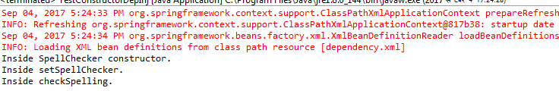

- Injecting Collections :
You have seen how to configure primitive data type using value attribute and object
References using ref attribute of the <property> tag in your Bean configuration file. Both the cases deal with passing a singular value to a bean.

Now what if you want to pass plural values like Java Collection types such as List, Set,
Map and Properties. To handle the situation, Spring offers four types of collection
Configuration elements which are as follows:

Element | Description
<list> | This helps in wiring i.e., injecting a list of values, allowing duplicates.
<set> | This helps in wiring a set of values but without any duplicates.
<map> | This can be used to inject a collection of name-value pairs where the name  and the value can be of any type.
<props> | This can be used to inject a collection of name-value pairs where the name  and the values are both Strings.

You can use either <list> or <set> to wire any implementation of java.util.Collection or
an array.
You will come across two situations (a) Passing direct values of the collection and (b)
Passing a reference of a bean as one of the collection elements.

Example:

JavaCollection.java:

package com.incredible.dependency.injection;

import java.util.*;

public class JavaCollection {
List addressList;
Set addressSet;
Map addressMap;
Properties addressProp;

// a setter method to set List
public void setAddressList(List addressList) {
this.addressList = addressList;
}

// prints and returns all the elements of the list.
public List getAddressList() {
System.out.println("List Elements :" + addressList);
return addressList;
}

// a setter method to set Set
public void setAddressSet(Set addressSet) {
this.addressSet = addressSet;
}

// prints and returns all the elements of the Set.
public Set getAddressSet() {
System.out.println("Set Elements :" + addressSet);
return addressSet;
}

// a setter method to set Map
public void setAddressMap(Map addressMap) {
this.addressMap = addressMap;
}

// prints and returns all the elements of the Map.
public Map getAddressMap() {
System.out.println("Map Elements :" + addressMap);
return addressMap;
}

// a setter method to set Property
public void setAddressProp(Properties addressProp) {
this.addressProp = addressProp;
}

// prints and returns all the elements of the Property.
public Properties getAddressProp() {
System.out.println("Property Elements :" + addressProp);
return addressProp;
}
}

Collection.xml:

<?xml version="1.0" encoding="UTF-8"?>
<beans xmlns="http://www.springframework.org/schema/beans"
xmlns:xsi="http://www.w3.org/2001/XMLSchema-instance"
xsi:schemaLocation="http://www.springframework.org/schema/beans
http://www.springframework.org/schema/beans/spring-beans-3.0.xsd">
<!-- Definition for javaCollection -->
<bean id="javaCollection" class="com.incredible.dependency.injection.JavaCollection">
<!-- results in a setAddressList(java.util.List) call -->
<property name="addressList">
<list>
<value>INDIA</value>
<value>Pakistan</value>
<value>USA</value>
<value>USA</value>
</list>
</property>
<!-- results in a setAddressSet(java.util.Set) call -->
<property name="addressSet">
<set>
<value>INDIA</value>
<value>Pakistan</value>
<value>USA</value>
<value>USA</value>
</set>
</property>
<!-- results in a setAddressMap(java.util.Map) call -->
<property name="addressMap">
<map>
<entry key="1" value="INDIA" />
<entry key="2" value="Pakistan" />
<entry key="3" value="USA" />
<entry key="4" value="USA" />
</map>
</property>
<!-- results in a setAddressProp(java.util.Properties) call -->
<property name="addressProp">
<props>
<prop key="one">INDIA</prop>
<prop key="two">Pakistan</prop>
<prop key="three">USA</prop>
<prop key="four">USA</prop>
</props>
</property>
</bean>
</beans>

TestCollection.java:

package com.incredible.dependency.injection;

import org.springframework.context.ApplicationContext;
import org.springframework.context.support.ClassPathXmlApplicationContext;

public class TestCollectionInj {
public static void main(String[] args) {
ApplicationContext context =
new ClassPathXmlApplicationContext("collection.xml");
JavaCollection jc=(JavaCollection)context.getBean("javaCollection");
jc.getAddressList();
jc.getAddressSet();
jc.getAddressMap();
jc.getAddressProp();
}
}

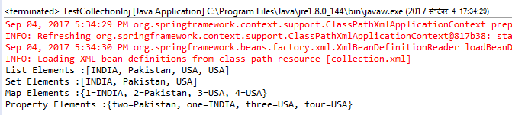

- Injecting Collection Bean References

<bean id="..." class="...">
<!-- Passing bean reference for java.util.List -->
<property name="addressList">
<list>
<ref bean="address1"/>
<ref bean="address2"/>
<value>Pakistan</value>
</list>
</property>
<!-- Passing bean reference for java.util.Set -->
<property name="addressSet">
<set>
<ref bean="address1"/>
<ref bean="address2"/>
<value>Pakistan</value>
</set>
</property>
<!-- Passing bean reference for java.util.Map -->
<property name="addressMap">
<map>
<entry key="one" value="INDIA"/>
<entry key ="two" value-ref="address1"/>
<entry key ="three" value-ref="address2"/>
</map>
</property>
</bean>

- Spring Beans Autowiring :

Usually we provide bean configuration details in the spring bean configuration file and specify the beans that will be injected in other beans using ref attribute or using an inner bean.

Spring framework provides an autowiring feature with which we need not to use ref attribute and provide bean references explicitly instead we can configure the auto-wire mode and spring container automatically wires the beans.
We can configure auto wire mode using “autowire” attribute (refer below snippet).

<bean id="bean_id" class="bean_class" autowire="default | byname | byType | constructor | autodetect " />

Following are the different autowiring modes supported by Spring.
- Default or no
- byname
- byType
- constructor
- autodetect

With spring 2.5 onwards , we can use following annotations as well
- @Autowired
- @Qualifier
Note:

- Explicit dependencies using <property> and <constructor-arg> settings always override the auto wiring.
- Currently not possible to autowire simple properties such as String, primitive types, collections etc.

- Autowiring byName :

This mode specifies autowiring by property name. Spring container looks at the beans on which auto-wire attribute is set to byName in the XML configuration file. It then tries to match and wire its properties with the beans defined by the same names in the configuration file. If matches are found, it will inject those beans. Otherwise, it will throw exceptions.

For example, if a bean definition is set to autowire byName in the configuration file, and it contains a spellChecker property (that is, it has a setSpellChecker(...)method), Spring looks for a bean definition named spellChecker, and uses it to set the property. Still you can wire the remaining properties using <property> tags.

<bean id="textEditor" class="com.incredible.dependency.injection.TextEditor" autowire="byName"/>
<beanid="spellChecker" class="com.incredible.dependency.injection.SpellChecker" />

- Autowiring byType:

This mode specifies autowiring by property type. Spring container looks at the beans on which autowire attribute is set to byType in the XML configuration file. It then tries to match and wire a property if its type matches with exactly one of the beans name in the configuration file. If matches are found, it will inject those beans. Otherwise, it will throw exceptions.

For example, if a bean definition is set to autowire byType in the configuration file, and it contains a spellChecker property of SpellChecker type, Spring looks for a bean definition named SpellChecker, and uses it to set the property. Still you can wire the remaining properties using <property> tags.

<bean id="textEditor" class="com.incredible.dependency.injection.TextEditor" autowire="byType"/>
<beanid="spellChecker" class="com.incredible.dependency.injection.SpellChecker" />

- Autowiring by Constructor :

This mode is very similar to byType, but it applies to constructor arguments. Spring container looks at the beans on which autowire attribute is set toconstructor in the XML configuration file. It then tries to match and wire its constructor's argument with exactly one of the beans name in the configuration file. If matches are found, it will inject those beans. Otherwise, it will throw exceptions.

For example, if a bean definition is set to autowire by constructor in the configuration file,and it has a constructor with one of the arguments ofSpellChecker type, Spring looks for a bean definition named SpellChecker, and uses it to set the constructor's argument. Still you can wire the remaining arguments using <constructor-arg> tags.

<bean id="textEditor" class="com.incredible.dependency.injection.TextEditor" autowire="constructor"/>
<beanid="spellChecker" class="com.incredible.dependency.injection.SpellChecker" />

You can use byType or constructor autowiring mode to wire arrays and other typedcollections.

- Autowiring by no :

Default value of autowire attribute of bean is “default” which means no autowiring will be performed. Setting autowire attribute with value “no” will have the same behavior.
<bean id="bean_id" class="bean_class" autowire="default"/>
<bean id="bean_id" class="bean_class" autowire="no "/>
<bean id="bean_id" class="bean_class" />

